‘Trash Talk’ Review: What Did You Just Say?

Getting into an opponent’s head with the bravado of boxing’s prefight press conference and the insults of a comedian’s roast.

Trash Talk: The Only Book About Destroying Your Rivals That Isn’t Total Garbage

By Rafi Kohan

PublicAffairs

336 pages

By
David Papineau
Dec. 14, 2023 6:23 pm ET
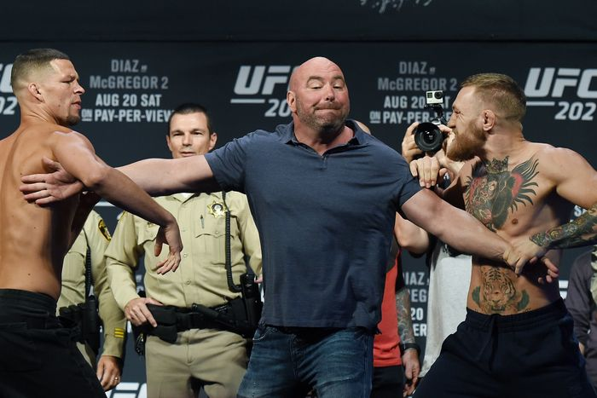UFC president Dana White separates Nate Diaz and Conor McGregor in 2016. PHOTO: ETHAN MILLER/GETTY IMAGES

In sports, as in life, the letter of the law is only a rough guide to good behavior. In basketball it is perfectly proper to commit a deliberate foul to stop the clock when you are trailing narrowly and time is running out. In that situation, breaking the rules is precisely what you are supposed to do. On the other hand, the rules of baseball say nothing about flipping your bat after hitting a home run. Yet all who do so will be condemned for insulting their opponents.
Different sports vary in how far their unwritten codes tolerate deviations from the official rules. In golf any infraction is a no-no, to the extent that players are expected to call their own fouls for the slightest infringement. Other sports are more selective, licensing some infractions but not others. Fighting is acceptable in hockey, but only with fists and not sticks. Soccer players will do anything to fool the referee, but regard reckless, injury-threatening tackles as beyond the pale.
These disparities do not mean that some sports are more moral than others. They are, rather, a matter of different traditions. In each case the athletes have evolved a workable set of conventions, an agreed sense of what they can expect from each other when playing their games. The fans of one sport will often look down on other games as ill-mannered and uncouth. But for the most part this simply exposes their insularity. It is like condemning other cultures for their different systems of social etiquette.
By their nature, though, unwritten codes are difficult to police. It is the job of athletes to compete, and this gives them reason to push the envelope of acceptable behavior in the hope of gaining some novel advantage—thus there’s spitballing in baseball, flopping in basketball, feigning injuries in soccer. The authorities may feel these practices diminish the attraction of their sports, but raising the penalties for those who are caught often does little to influence the culture of the athletes.
In “Trash Talk,” Rafi Kohan presents an extreme case of this problem. Athletic success requires a clear head, an exclusive focus on the competitive task at hand. So an adversary who can discombobulate you with a few well-chosen words is already halfway to victory. Many sports have established customs of “talking trash,” challenging opponents with a series of slurs and slights. Often this can be witty and good-humored, but the practice has a built-in tendency toward viciousness. Indecent abuse is a surer way of getting inside your antagonist’s head than a clever put-down, and once that line has been crossed it can be difficult to restore it.
Mr. Kohan’s comprehensive survey ranges widely over the issues raised by in-game invective. As he explains, the term “trash talk” only gained currency in the 1990s, but the custom itself has long been known by other names—“bench jockeying” in baseball, “chirping” in hockey, “sledging” in cricket. Mr. Kohan—whose previous book, “The Arena,” examined the many facets of the American sports stadium—traces the tradition of trading abuse in physical contests back to Homer and the Bible.
The book is informed by a great wealth of interviews, not only with athletes past and present, but also with match officials, coaches and sports psychologists. Given that trash-talking is essentially designed for private consumption, sports fans will welcome the insider’s perspective that Mr. Kohan is able to provide.
In his enthusiasm to cover every last facet of trash talk, Mr. Kohan casts his net wide. As well as dissecting the in-game exchanges of athletes, he has much to say about the oratorical shtick of professional wrestlers and the prefight ballyhoo designed to sell boxing tickets, not to mention the training regimes used to forge psychological resilience in special military troops and even the experiences of comedians who trade insults in “roast battles.” Curiously, in the midst of all this analysis, the humor itself takes a back seat. Mr. Kohan offers plenty of insights into the psychology of giving and receiving insults, but he doesn’t quote many quips, and readers hoping to add to their store of clever put-downs might come away disappointed.
Toward the end of the book, Mr. Kohan turns to the issue of unacceptable abuse. Since trash talk is almost impossible for the officials to police, and given the win-at-all-costs mentality of modern money-making sports, what is to stop trash-talking from spiraling into a race to the bottom? Somewhat surprisingly, though, the increasing professionalism of major sports seems to have acted as a brake on verbal excess. For a start, raising the stakes is often a double-edged sword. When the invective gets too heated, it can be the speaker who gets hot under the collar and the hearer whose resolve is reinforced. Modern professionals choose their verbal weapons with care, and this tendency has been accentuated by increased free agency and the likelihood that today’s abusee will become tomorrow’s teammate.
In the last resort, the players themselves can always blow the whistle when things go too far. Mr. Kohan finishes the book by describing how in 2020 the San Diego Loyal soccer team collectively agreed to forfeit one game and abandon another as a reaction to racist and homophobic abuse by opposing players. Athletes calling out offensive provocation in this way is becoming more common, and this provides a bulwark against unacceptable verbal abuse. Trash talk may fly under the radar of the official rule book, but the unwritten code of the players still has the power to hold it in check.
Mr. Papineau is a professor of philosophy at King’s College London. He is the author of “Knowing the Score.”
Copyright ©2023 Dow Jones & Company, Inc. All Rights Reserved. 87990cbe856818d5eddac44c7b1cdeb8
Appeared in the December 15, 2023, print edition as 'What Did You Just Say?'.
